 | 7.0.13 Editors - 3D Viewport - Grease Pencil object - Edit Mode - Stroke context menu
Table of content
Detailed table of content 1
Edit Mode - Stroke Context Menu 4
Subdivide 4
Subdivide and Smooth 5
Set Stroke Type - Sub Menu 6
Transform – Sub Menu 6
Smooth 7
Move to Layer - Sub Menu 8
Assign Material - Sub Menu 8
Set as active material 9
Arrange Strokes - Sub Menu 9
Mirror - Sub Menu 10
Snap – Sub Menu 10
Duplicate 10
Copy 11
Paste 12
Paste by Layer 12
Outline 12
Split 12
Separate 13

Detailed table of content
Detailed table of content
Detailed table of content 1
Edit Mode - Stroke Context Menu 4
Subdivide 4
Last Operator Subdivide 4
Number of Cuts 4
Smooth 4
Repeat 4
Selected Points 4
Position 4
Thickness 5
Strength 5
UV 5
Subdivide and Smooth 5
Last Operator Subdivide and Smooth 5
Number of Cuts 5
Selected Points 5
Iterations 5
Factor 5
Smooth Endpoints 5
Keep Shape 5
Position 5
Radius 5
Opacity 6
Set Stroke Type - Sub Menu 6
Stroke 6
Fill 6
Both 6
Transform – Sub Menu 6
To Sphere 6
Shear 6
Bend 7
Push/Pull 7
Radius 7
Opacity 7
Smooth 7
Last Operator Smooth Stroke 7
Repeat 7
Factor 7
Selected points 7
Position 7
Thickness 7
Strength 8
UV's 8
Move to Layer - Sub Menu 8
New Layer 8
Last Operator Move Strokes to Layer 8
Grease Pencil Layer 8
Assign Material - Sub Menu 8
Last Operator Change Stroke Color 9
Material 9
Set as active material 9
Arrange Strokes - Sub Menu 9
Bring Forward 9
Send Backward 9
Bring to Front 9
Send to Back 9
Last Operator Arrange Stroke 9
Direction 9
Mirror - Sub Menu 10
Interactive Mirror 10
X Global, Y Global etc. 10
Last Operator Mirror 10
Orientation 10
Constraint Axis 10
Snap – Sub Menu 10
Last Operator Snap 10
Offset 10
Duplicate 10
Last Operator Duplicate Strokes 11
Mode 11
Move X, Y, Z 11
Orientation 11
Constraint Axis 11
Mirror Editing 11
Proportional editing 11
Proportional Falloff 11
Proportional Size 11
Connected 11
Projected(2D) 11
Copy 11
Paste 12
Paste by Layer 12
Last operator Paste Strokes 12
Type 12
Outline 12
Last Operator Outline 12
Projection Mode 12
Radius 12
Offset Factor 12
Corner Subdivisions 12
Split 12
Separate 13
Last Operator Separate Strokes 13
Mode 13
Active Layer 13
Selected Strokes 13
Selected Points 13

Edit Mode - Stroke Context Menu

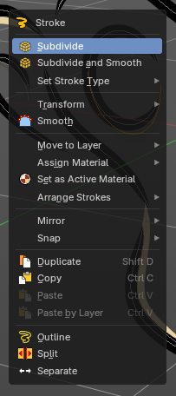
Call this menu with right click in the 3D viewport. The stroke menu appears in select mode stroke and segment
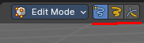

Subdivide
Subdivides the selected grease pencil geometry.

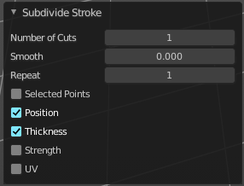
Last Operator Subdivide

Number of Cuts
Number of subdivision cuts.

Smooth
Smoothen the stroke, not just the new added vertices

Repeat
The number of times to repeat the procedure.

Selected Points
Limits the effect to only the selected points within the stroke.

Position
The operator affects the points location.

Thickness
The operator affect the points thickness.

Strength
The operator affect the points strength (alpha).

UV
The operator affect the UV rotation on the points.

Subdivide and Smooth
Subdivides the selected grease pencil geometry.

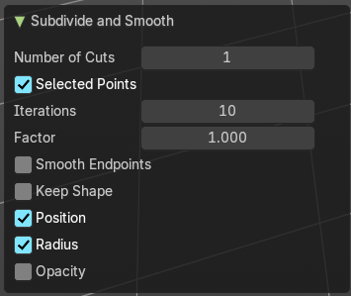
Last Operator Subdivide and Smooth

Number of Cuts
Number of subdivision cuts.

Selected Points
Limits the effect to only the selected points within the stroke.

Iterations
Number of iterations.

Factor
Smooth factor

Smooth Endpoints
Smooth endpoints too.

Keep Shape
Keep the overall shape.

Position
The operator affects the points location.

Radius
Smooth radius.

Opacity
Smooth Opacity.

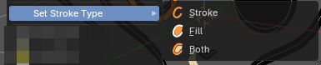
Set Stroke Type - Sub Menu
Defines how selected points are interpreted on the Grease Pencil.

Stroke
Points are treated as part of a line stroke.

Fill
Points are treated as part of a filled region.

Both
Points contribute to both stroke and fill.

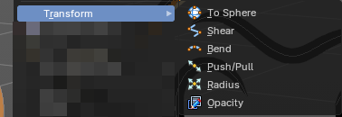
Transform – Sub Menu
Provides geometric and visual transformations for selected Grease Pencil points or strokes.
Useful for reshaping, stylizing, and refining drawings with precise control

To Sphere
Moves selected points toward a spherical distribution.
– Strength slider controls how tightly points conform to a sphere.
– Useful for rounding shapes or creating circular strokes.

Shear
Skews selected points along a chosen axis.
– Creates slanted or diagonal distortions.
– Ideal for stylized perspective effects or dynamic motion exaggeration.

Bend
Bends selected points around a pivot.
– Angle and pivot settings define curvature.
– Useful for wrapping strokes into arcs or circular motifs.

Push/Pull
Moves selected points outward or inward relative to their median center.
– Push expands the shape; Pull contracts it.
– Useful for inflating or compressing stroke geometry.

Radius
Adjusts the thickness (point radius) of selected vertices.
– Larger radius = thicker stroke segments.
– Useful for line weight variation or emphasis.

Opacity
Changes the transparency of selected vertices.
– Higher values = more opaque; lower values = more transparent.
– Useful for shading, layering, or fade effects in drawings.

Smooth
Smoothens out the selected geometry.

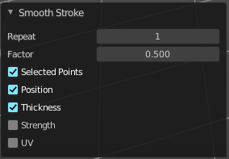
Last Operator Smooth Stroke

Repeat
How often to repeat the procedure.

Factor
The amount of the smoothness to apply.

Selected points
When enabled, limits the effect to only the selected points within the stroke.

Position
When enabled, the operator affect the points location.

Thickness
When enabled, the operator affect the points thickness.

Strength
When enabled, the operator affect the points strength (alpha).

UV's
When enabled, the operator affect the UV rotation on the points.

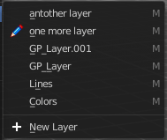
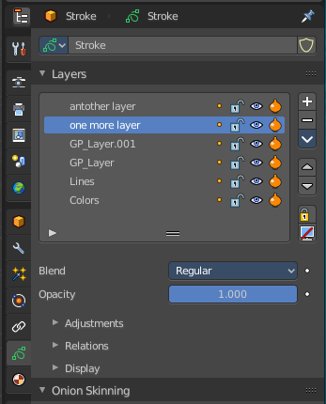
Move to Layer - Sub Menu
Move the current selected stroke to another grease pencil layer. It lists the current layers.

New Layer
New Layer button adds a new grease pencil layer.

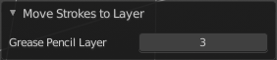
Last Operator Move Strokes to Layer

Grease Pencil Layer
Internal the layers are enumerated. So here you move by number.
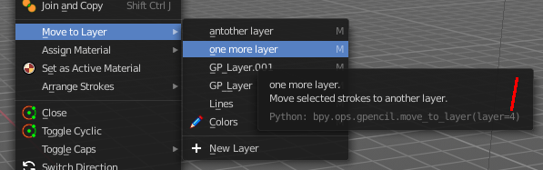
The number of a layer can be found out in the tool tip, in the Python part of it.

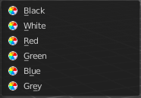
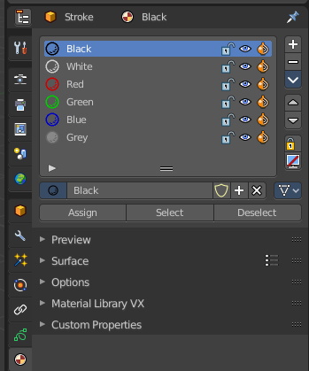
Assign Material - Sub Menu
Assign a new material to the current selected stroke geometry.
The materials can be found and edited in the Properties editor. Here you can also create new materials.

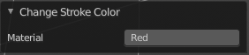
Last Operator Change Stroke Color

Material
The materials are defined by its name. So when you want to use another material, then change the name here.

Set as active material
Sets the current selected material as the active material.

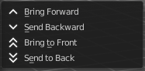
Arrange Strokes - Sub Menu
Changes the drawing order of the strokes in the 2D layer.

Bring Forward
Moves the selected points/strokes upper the next one in the drawing order.

Send Backward
Moves the selected points/strokes below the previous one in the drawing order.

Bring to Front
Moves to the top the selected points/strokes.

Send to Back
Moves to the bottom the selected points/strokes.

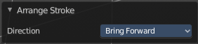
Last Operator Arrange Stroke

Direction
Choose the method again.

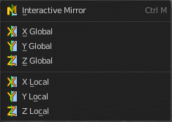
Mirror - Sub Menu
Mirror mirrors the selected geometry along the defined axis.

Interactive Mirror
Mirror by hotkeys. You activate the tool, type in x for x global for example, or x x for x local. And the selection gets mirrored.

X Global, Y Global etc.
Mirrors the selection around the chosen axis.

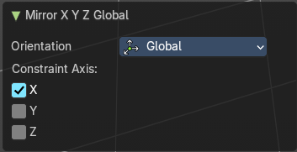
Last Operator Mirror
The Last Operator Mirror panel gives you tools to adjust the mirror action.

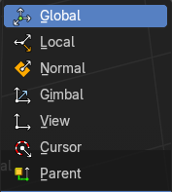
Orientation
Orientation is a drop-down box. Choose the type of orientation for the mirroring action.

Constraint Axis
Constraint Axis gives you again the possibility to define the mirror axis. You can choose more than one axis here.

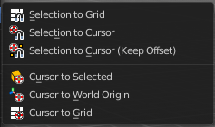
Snap – Sub Menu
Choose several methods to snap one element to another. The menu items should be self explaining.

Last Operator Snap
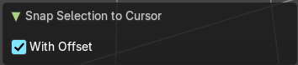
Some snap operations shows a last operation panel, some not.

Offset
If the selection should snap as a whole, or if each individual element of the selection should snap.

Duplicate
Duplicates the current selection.
When you duplicate a selection, then it sticks to the mouse until you left click. And moves around. A right click repositions the duplicated geometry at its original location.

Last Operator Duplicate Strokes

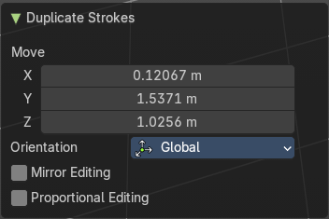
Mode
Not to find out. No tool tip, no entry in the Blender manual. Good Job Blender Developers.

Move X, Y, Z
Adjust the position.

Orientation
Orientation is a drop-down box. Choose the type of orientation for the mirroring action.

Constraint Axis
Constraint Axis gives you again the possibility to define the mirror axis. You can choose more than one axis here.

Mirror Editing
Edit along a mirror axis.

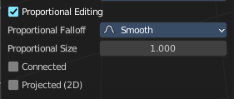
Proportional editing
Enables proportional editing. Activating proportional editing reveals further settings.

Proportional Falloff
Adjust the falloff methods.

Proportional Size
See and adjust the falloff radius.

Connected
The proportional falloff gets calculated for connected parts only.

Projected(2D)
The proportional falloff gets calculated in the screen space. Depth doesn't play a role. When it's in the radius, then it gets calculated.

Copy
Copies the selection.

Paste
Pastes a copied selection to active layer. You can have more than one layer.

Paste by Layer
Pastes a copied selection to same, original layer. You can have more than one layer.

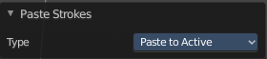
Last operator Paste Strokes

Type
Choose between the paste methods again.

Outline
Adds an outline to the grease pencil.

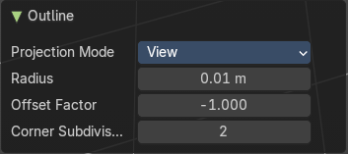
Last Operator Outline

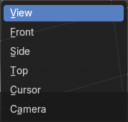
Projection Mode
The orientation to project the outline.

Radius
Thickness of the outline

Offset Factor
Offset from original outline.

Corner Subdivisions
How much iterations to subdivide the corners.

Split
Splits the selection.

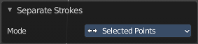
Separate
Separates the selection into a new grease pencil object.

Last Operator Separate Strokes

Mode

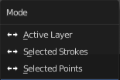
Active Layer
Separate all the strokes at the current active layer.

Selected Strokes
Separate the whole stroke of the current selection.

Selected Points
Separate the selected points with its edges.

